# Lab 15: Form Values to State

## Objectives

*  Add form data to component state
*  Make form fields controlled components
*  Handle submission of the form

## Steps

### Add form data to component state

1. **Open** the **file** src\projects\ProjectForm.js.
2. To the propTypes, add a project prop.

#### src\projects\ProjectForm.js

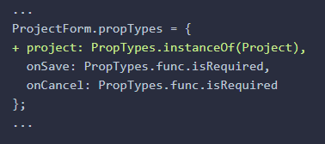

1. **Destructure** the project prop in the function component signature and **rename** it initialProject so that we can name our state variable project. Next, **create** a state variable project using the useState hook.

#### src\projects\ProjectForm.js

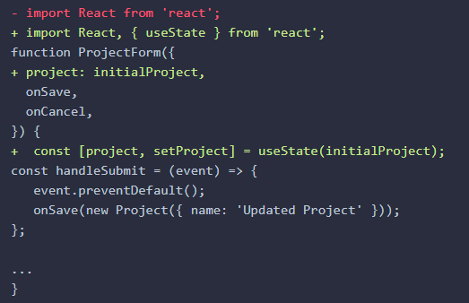

### Make form fields controlled components

1. **Make** all <input />s and <textarea />s **controlled** **components** by assigning their values to a project property on state.

* **Write** a handleChange event handler and wire it up to onChange event of all the form fields.
* The form field **types** that need to be handled include:
* <input type="text" />
* <input type="number" />
* <input type="checkbox" />
* <textarea />

Alternatively, you could write a separate handler for each of the form field types and invoke them as appropriate but this can be tedious and more difficult to maintain.

#### src\projects\ProjectForm.js

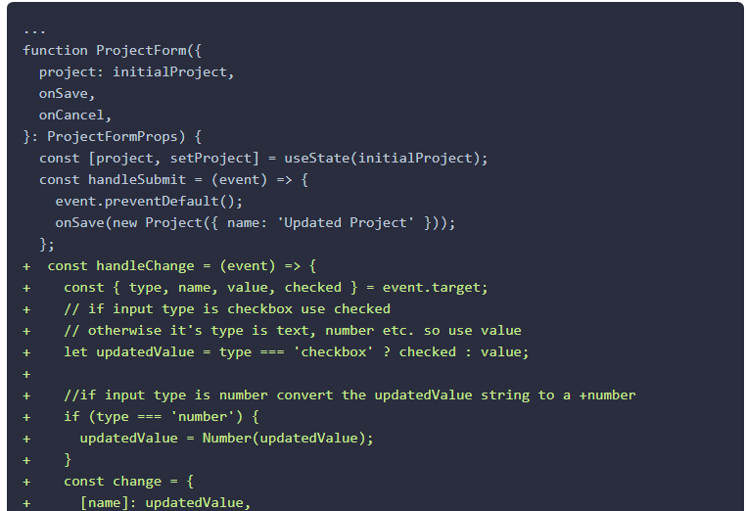

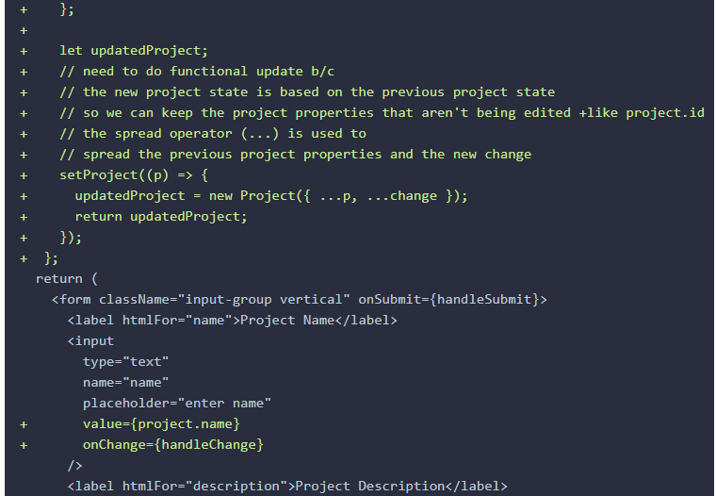

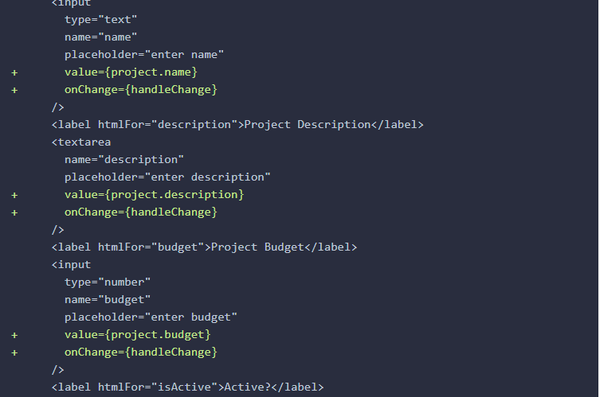

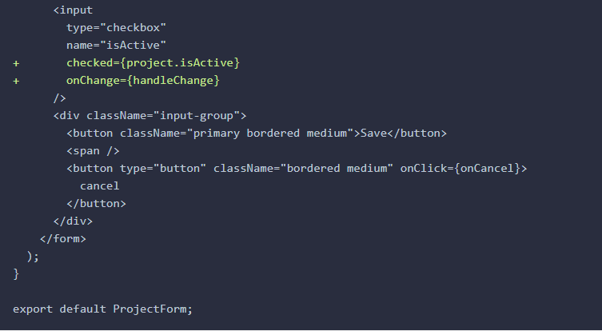

### Handle submission of the form

1. In handleSubmit, when calling the onSave prop pass state.project instead of new Project({ name: 'Updated Project' }).

#### src\projects\ProjectForm.js

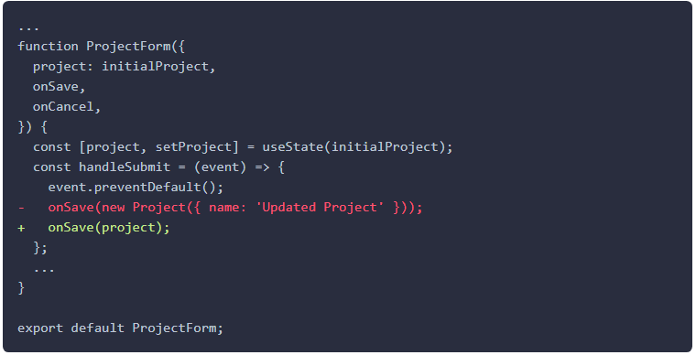

1. In ProjectList **set** the project **prop** into the <ProjectForm />.

#### src\projects\ProjecList.js

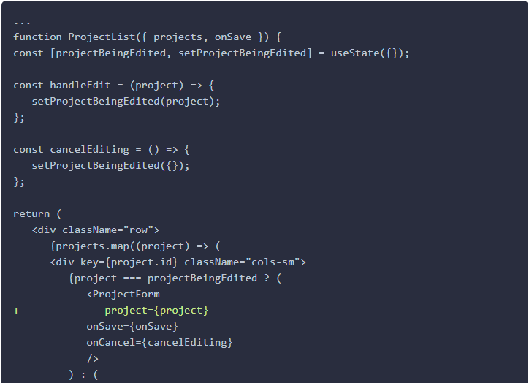

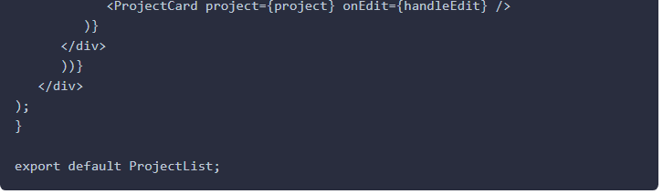

1. ProjectsPage update the project.

#### src\projects\ProjectsPage.js

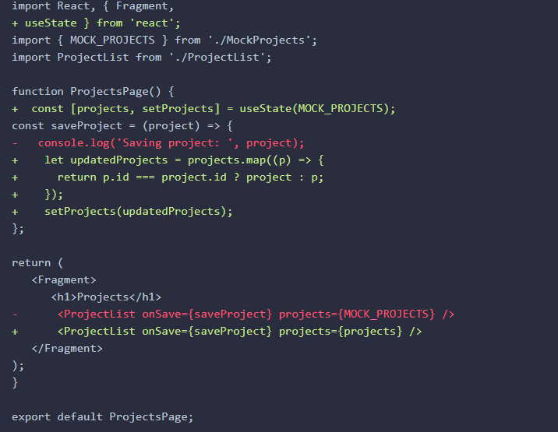

1. **Verify** the application is working by following these **steps** in your browser.
   1. **Click** the **edit** button for a project.
   2. **Change** the **project name** in the form.
   3. **Click** **save** on the form.
   4. **Verify** the card shows the **updated** data.

Note that if you refresh your browser page your changes will not persist because the updates are only happening in the browser's memory. We will get a more permanent save working in a future lab when we communicate to our backend web API.

### ✔ You have completed Lab 15